Alexander Baldree
07/24/26
Module 9.2 Project Part 4
CSD430

GitHub Link:
https://github.com/Panda-Alex21687/CSD430

Full Project Folder:
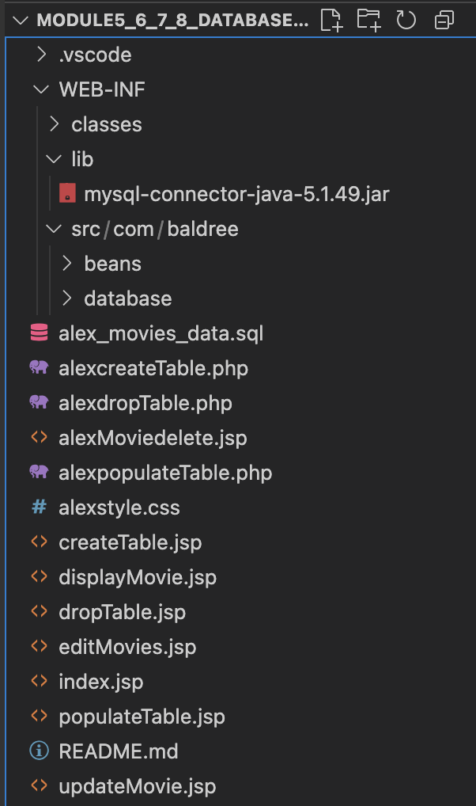

Delete Page:
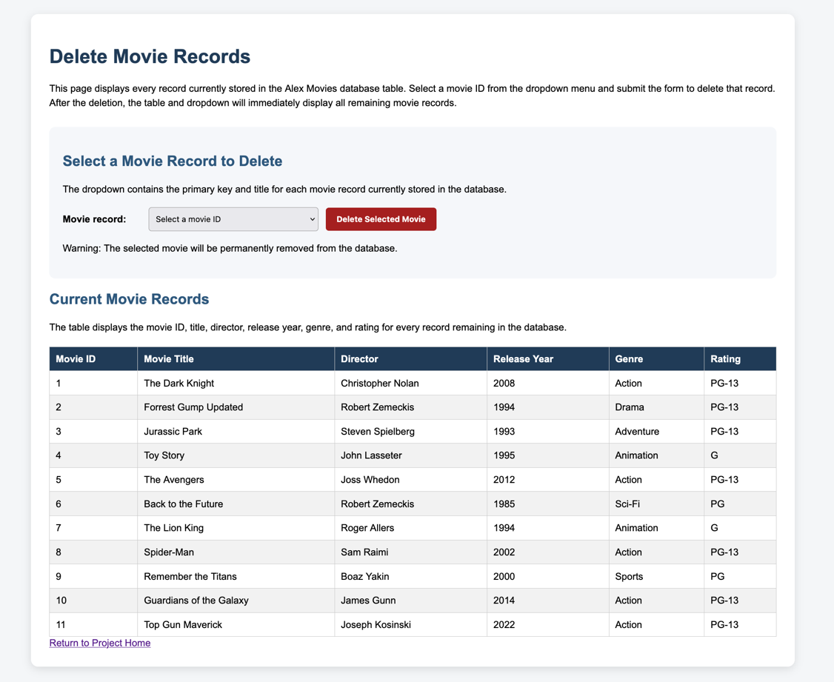

Dropdown Open:
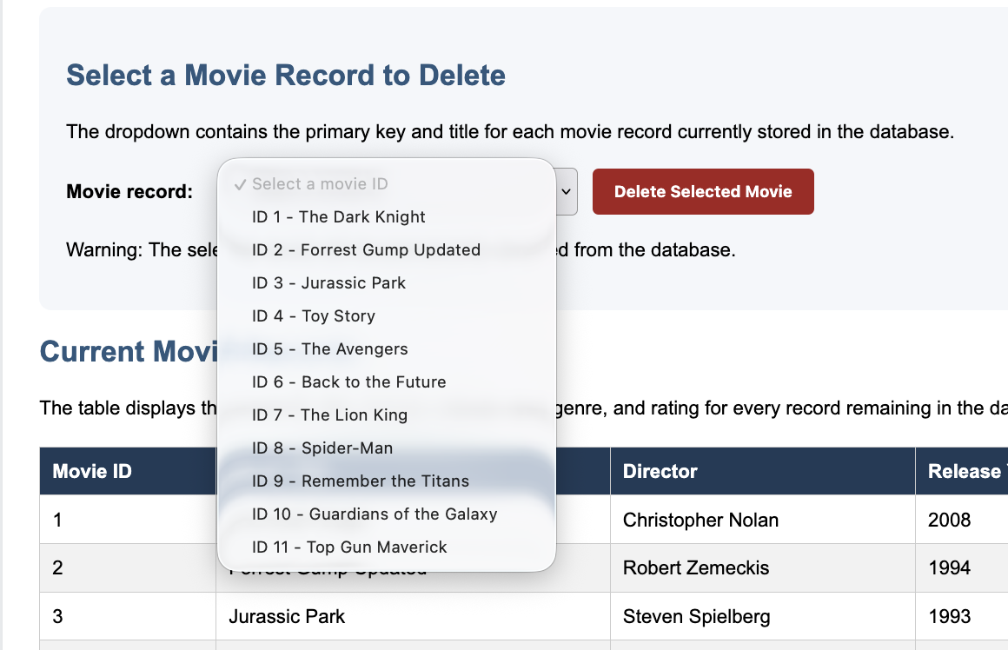

Movie Selected:
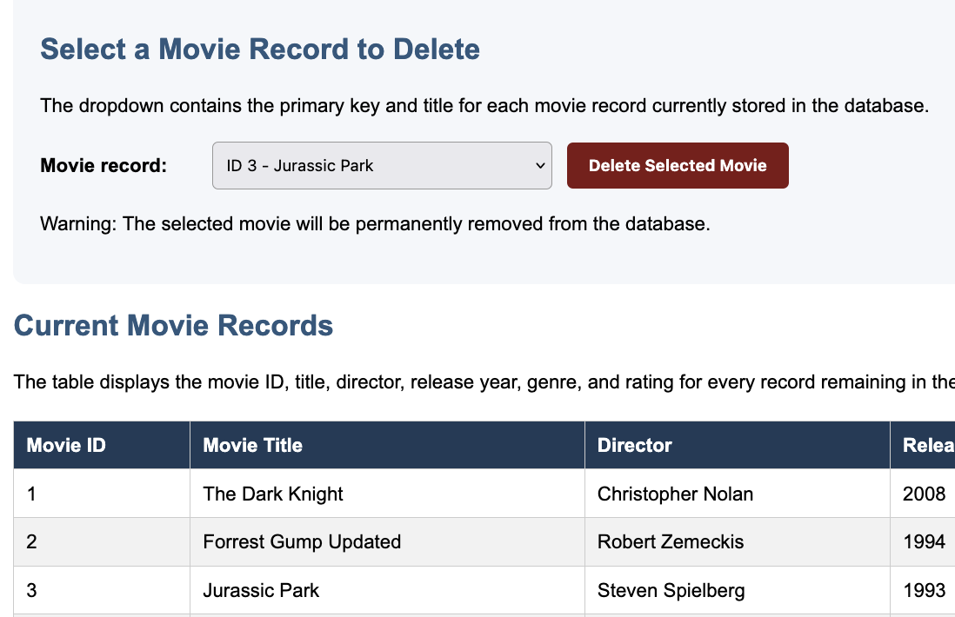

Successful Deletion:
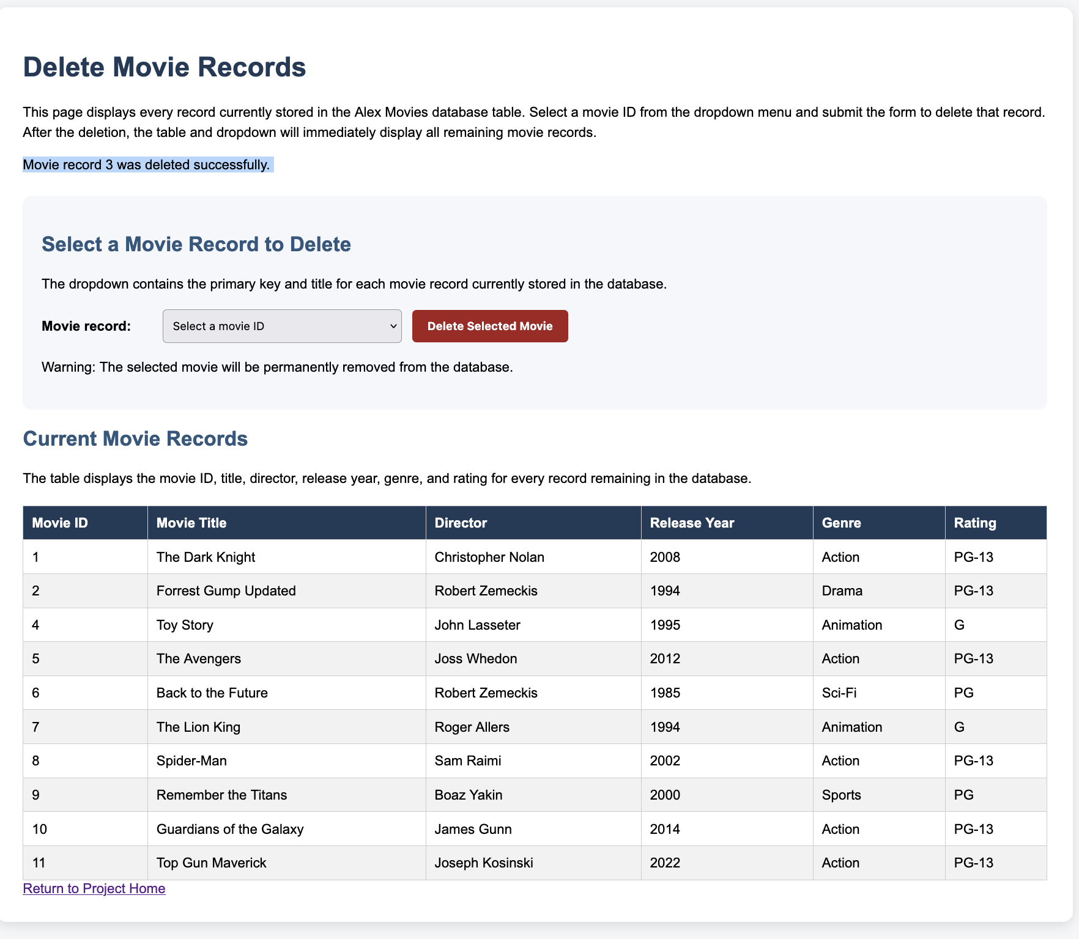

Deleted Record no longer in dropdown:
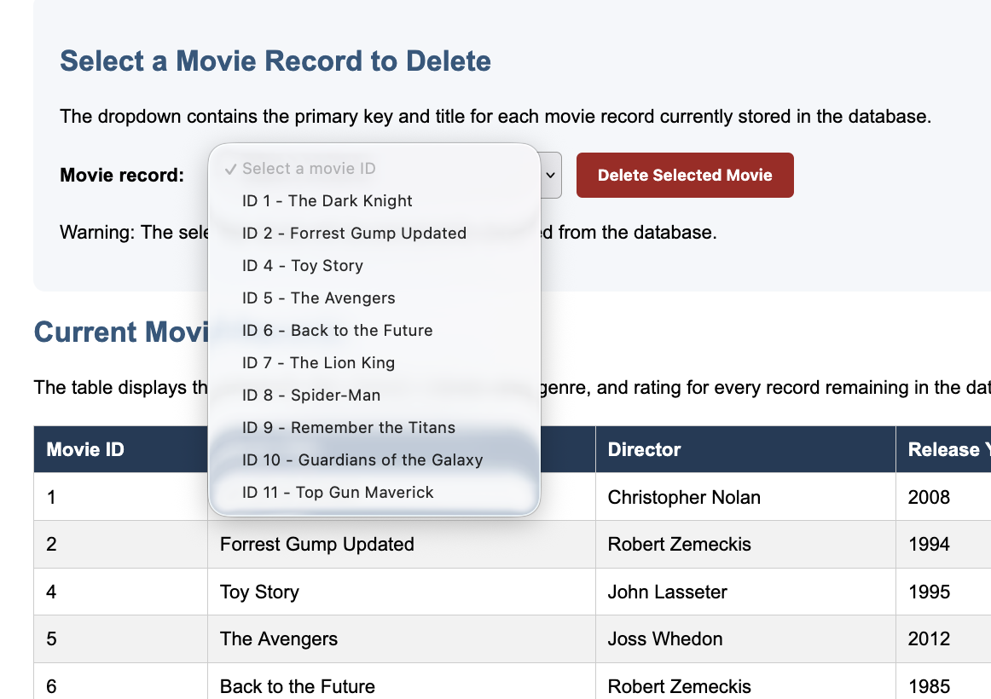

Every Record deleted and delete button disabled:
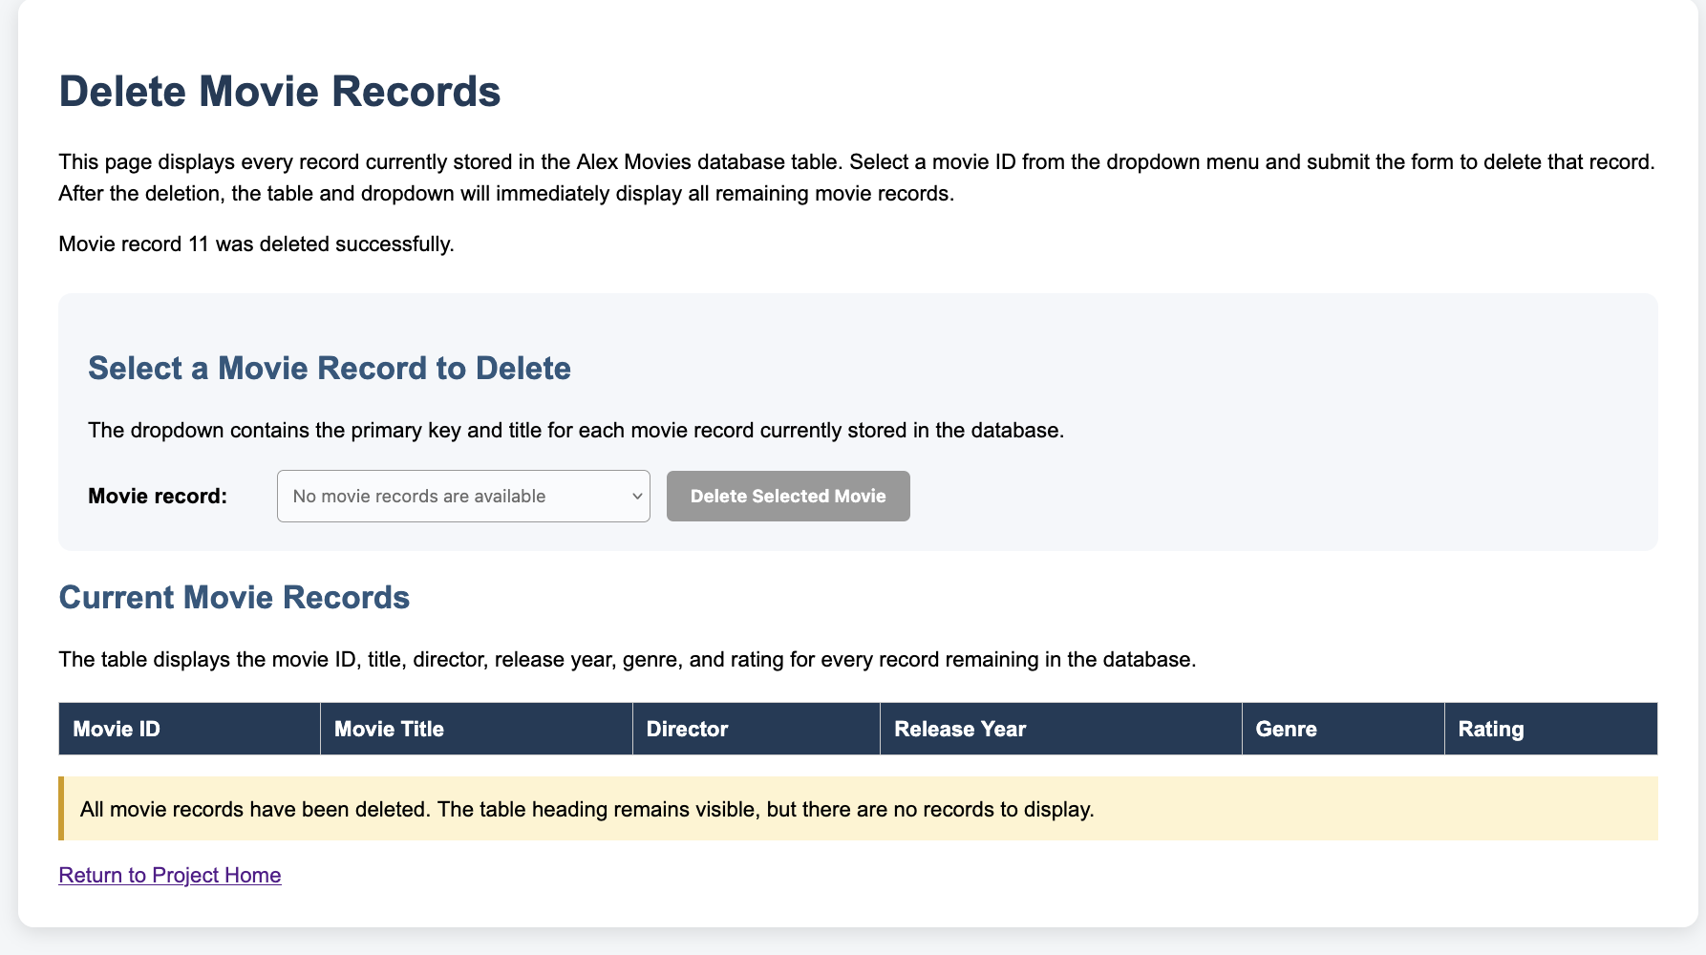

Restored Movie Records:
